- Statistics II
1. The table below shows the number of defective bolts from a sample of 40
No of bolts | 0 | 1 | 2 | 3 | 4 | 5
Frequency | 20 | 8 | 6 | 4 | 1 | 1
Calculate the standard deviation of the data above (4 mks)
2. The table below shows the masses to the nearest kg of all the students of marigu-ini secondary. School.

Masses (kg) | No. of students
30-34 | 5
35-39 | 7
40-44 | 10
45-49 | 10
50-54 | 19
55-59 | 20
60-64 | 20
65-69 | 6
70-74 | 2
75-79 | 1

- Taking the assumed mean A=52kg
Calculate:
  - the actual mean mass of the students. (3 marks)
  - the standard deviation of the distribution. (3 marks)
- Draw a cumulative frequency curve and use it to estimate the number of students whose masses lie
between 44.5kg and 59.5kg. (4 marks)

3. Sixty form four students in Tahidi high sat for a mathematics examination. Their marks were grouped into seven classes as follows: 30 – 34, 35 – 39, 40 – 44, 45 – 49, 50 – 54, 55 – 59, 60 – 64 and then named as cheetah, lion, zebra, rabbit, giraffe, elephant and buffalo respectively. The form 4 students population was then analyzed in the form of a pie-chart as shown below.
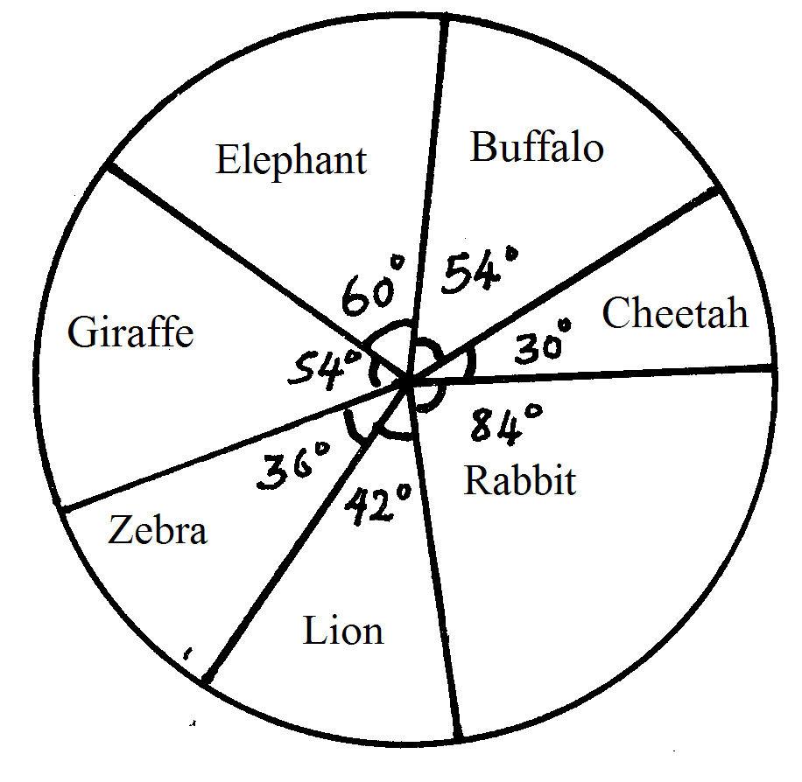
Using the information above
(a) Complete the table below.
Name | Marks | No. of students
Cheetah  Lion  Zebra  Rabbit  Giraffe  Elephant  Buffalo | 30-34  35-39  40-44  45-49  50-54  55-59  60-64
(2mks)
(b) Calculate the inter quartile range. (3mks)
(c) Using an assumed mean of 47, calculate the standard deviation of the data. (5mks)
4. At an agricultural Research Centre, the length of a sample of 50 maize cobs were measured and recorded as shown in the frequency distribution table below.

Length | 8 – 10 | 11 – 13 | 14 – 16 | 17 – 19 | 20 – 22 | 23 - 24
No. of Labs | 4 | 7 | 11 | 15 | 8 | 5

a) State the modal class and size. (2mks)
Calculate
b) the mean (3mks)
c) (i) the variance (3mks)
(ii) the standard deviation. (2mks)

5. The table below shows the masses to the nearest kg of a number of people.
Mass (kg)  Frequency | 50 – 54  19 | 55 – 59  23 | 60 – 64  40 | 65 – 69  28 | 70 – 74  17 | 75 – 79  9 | 80 – 84  4

a)Using an assumed mean of 67.0, calculate to one decimal place the mean mass.
(b) Calculate to one decimal place the standard deviation of the distribution.
6. Use only a ruler and pair of compasses in this question;
(a) construct triangle ABC in which AB = 7cm, BC = 6cm and AC = 5cm
(b) On the same diagram construct the circumcircle of triangle ABC and measure its radius

(c) Construct the tangent to the circle at C and the internal bisector of angle BAC. If these

lines meet at D, measure the length of AD
7. Below is a histogram drawn by a student of Got Osimbo Girls Secondary School.
Frequency density
Mass (Kg)
40.5
45.5
50.5
55.5
60.5
65.5
70.5
75.5
80.5
85.5
0
1
2
5
6
7
8
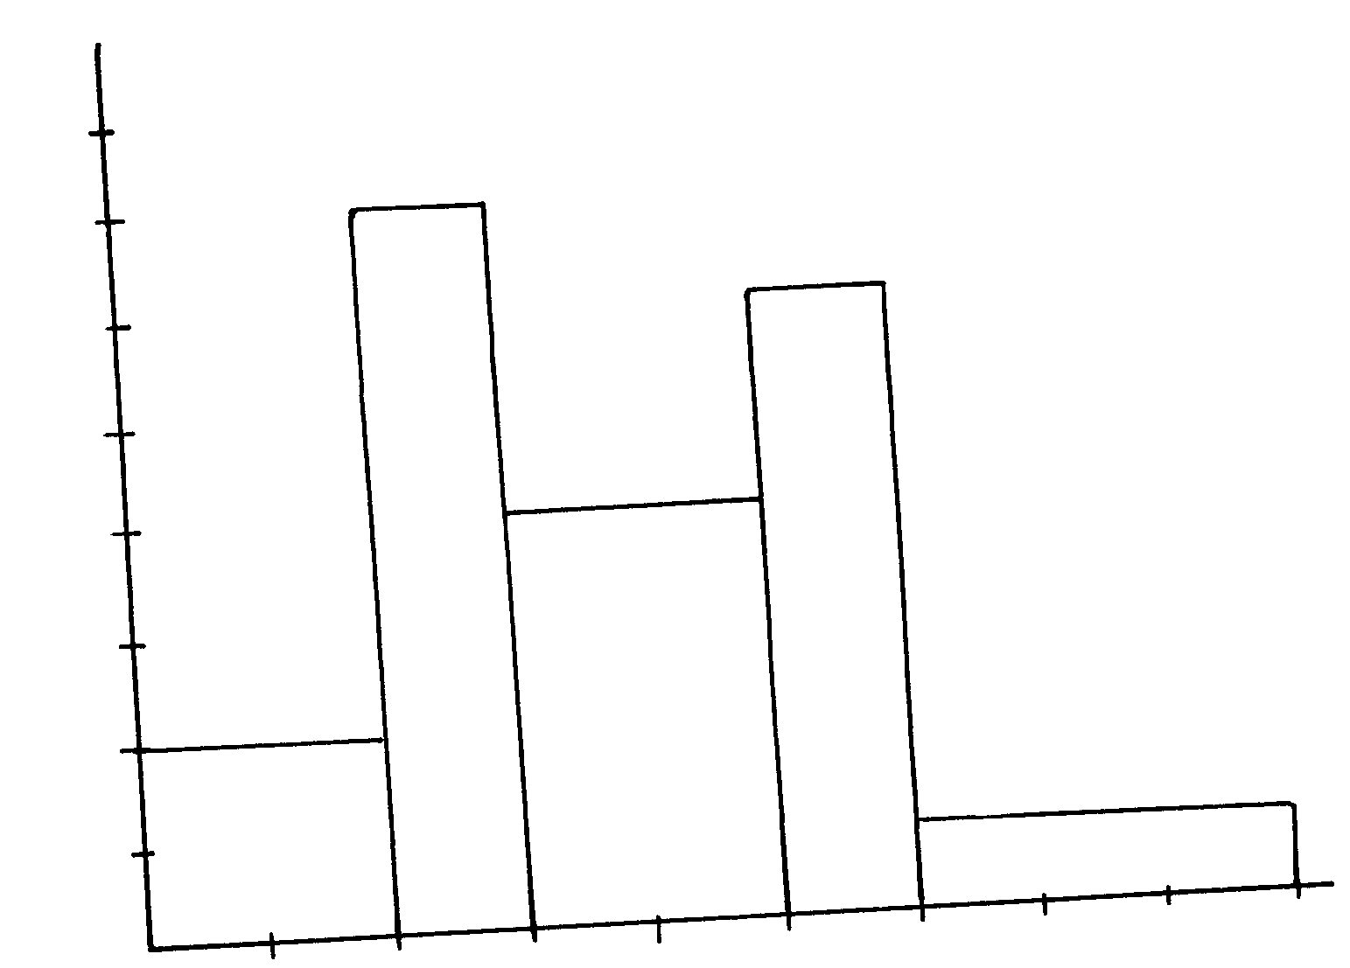

4

3

- Develop a frequency distribution table from the histogram above.
b) Use the frequency distribution table above to calculate;
i) The inter-quartile range.
ii) The sixth decile.

8. ABC is a triangle drawn to scale. A point x moves inside the triangle such that
i) AX ≤ 4 cm
ii) BX > CX
iii) Angle BCX ≤ Angle XCA.
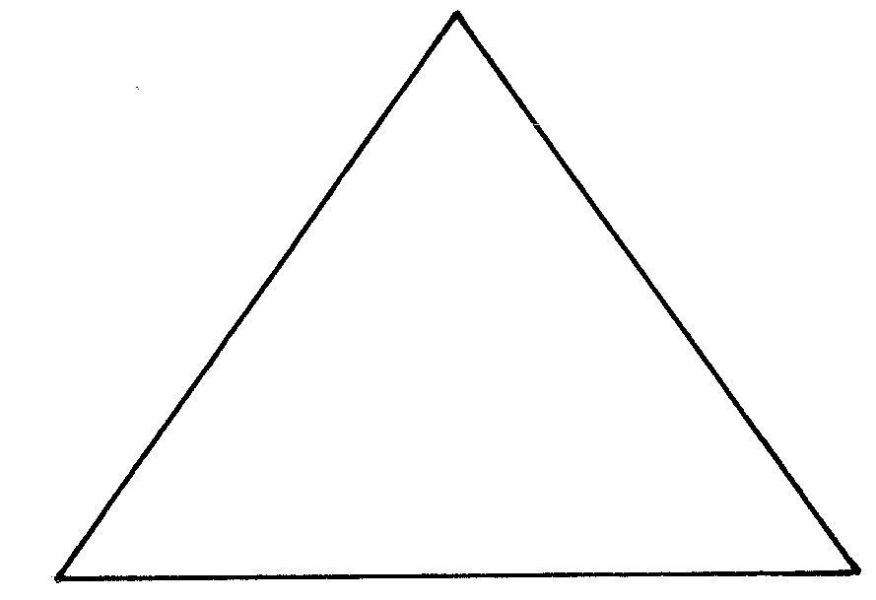
Show the locus of X.

6cm

7cm
55º

9. The following able shows the distribution of marks of 80 students

Marks | 1-10 | 11-20 | 21-30 | 31-40 | 41-50 | 51-60 | 61-70 | 71-80 | 81-90 | 91-100
Frequency | 1 | 6 | 10 | 20 | 15 | 5 | 14 | 5 | 3 | 1

(a) Calculate the mean mark
(b) Calculate the semi-interquartile range
(c) Workout the standard deviation for the distribution

10. The table below shows the marks of 90 students in a mathematical test

Marks | 5-9 | 10-14 | 15-19 | 20-24 | 25-29 | 30-34 | 35-39
No. of students | 2 | 13 | 31 | 23 | 14 | X | 1
- Find X
- State the modal class
(c) Using a working mean of 22, calculate the; i) Mean mark ii) Standard deviation

11. (a) Using a ruler and a pair of compasses only construct triangle PQR in which PQ = 5cm,
PR = 4cm and ∠PQR = 30º
(b) Measure; (i) RQ
(ii) ∠PQR
(c) Construct a circle, centre O such that the circle passes through vertices P, Q, and R (d) Calculate the area of the circle

12. The ages of 100 people who attended a wedding were recorded in the distribution table below
Age | 0-19 | 20-39 | 40-59 | 60-79 | 80-99
Frequency | 7 | 21 | 38 | 27 | 7
a) Draw the cumulative frequency
b) From the curve determine: i) Median ii) Inter quartile range iii) 7th Decile iv) 60th Percentile

13. The marks obtained by 10 students in a maths test were:-
25, 24, 22, 23, x, 26, 21, 23, 22 and 27
The sum of the squares of the marks, Σx² = 5154
(a) Calculate the: (i) value of x (ii) Standard deviation
(b) If each mark is increased by 3, write down the:-
(i) New mean
(ii) New standard deviation

14. 40 form four students sat for a mathematics test and their marks were distributed as follows:-

Marks | 1 – 10 | 11- 20 | 21- 30 | 31 – 40 | 41 – 50 | 51 – 60 | 61 – 70 | 71 – 80 | 81 – 90 | 91 - 100
No. of students | 1 | 3 | 4 | 7 | 12 | 9 | 2 | 1 | 0 | 1

a) Using 45.6 as the working mean, calculate;
i) The actual mean.
ii) The standard deviation.
b) When ranked from first to last, what mark was scored by the 30th student?
(Give your answer correct to 3 s.f.)

15. The table below shows the distribution of marks scored by pupils in a maths test at Nyabisawa
Girls.

Marks | 11 – 20 | 21 – 30 | 31 – 40 | 41 – 50 | 51 – 60 | 61 – 70 | 71 – 80 | 81 – 90
Frequency | 2 | 5 | 6 | 10 | 14 | 11 | 9 | 3

a)Using an Assumed mean 45.5, calculate the mean score.
b) Calculate the median mark.
c) Calculate the standard deviation.
d) State the modal class.

16. The table below shows the marks scored in a mathematics test by a form four class;

Marks | 20-29 | 30-39 | 40-49 | 50-59 | 60-69 | 70-79 | 80-89
No. of students | 4 | 26 | 72 | 53 | 25 | 9 | 11

(a) Using an assumed mean of 54.5, calculate:-
(i) The mean
(ii) The standard deviation
(b) Calculate the inter quartile range

